**Port Access Security System**

**(PASS)**

**User Guide**

TABLE OF CONTENTS

INTRODUCTION 3

SECURITY & COMPLIANCE 4

PORT/PIER ACCESS REQUIREMENTS: 5

PASS – Supplier Portal Log In 6

PASS – Home Page 8

CREATING YOUR COMPANY FILES 9

Begin creating your files by selecting Carriers 9

Continue by adding the Vehicles 12

Continue by adding the Drivers 14

ACTIVE and INACTIVE file records 15

CREATING A DELIVERY or PICKUP RECORD: 16

ACCESSING DELIVERY/PICKUP REPORTS: 19

HANDLING AN EMERGENCY: 22

Troubleshooting Errors: 23

Error Messages: 23

Web Browser Compatibility: 24

# INTRODUCTION

The Port Access Security System (PASS) is a web-based application developed by RCG to streamline the process of providing Advance Port Notification mandated by Homeland Security, and carried out by local Port Security Authorities.

The application was originally developed for use with Internet Explorer version 6 and does have some compatibility issues with Internet Explorer Version 9 and above, Mozilla Firefox and Google Chrome.

The PASS application is available 24/7.

The PASS system **does not include access to board the ship**.

*NOTE: A Fleet Visitor Request (FVR) is required to board the ship. These requests are processed by the department sponsoring the delivery/pickup. PASS and FVR are two separate processes.*

*If boarding the ship is required in addition to making a direct delivery of goods to a U.S. port/pier, the supplier must contact the sponsoring department or project manager at RCG. Supply Chain cannot process the FVR on their behalf.*

If you are an approved registered RCG supplier with an active supplier number and do not have access to the secured site, visit the site at the URL address noted above. Select the tab titled “About our Company” and select the RCG Supplier Portal Administrator Information Form for instructions on obtaining a Supplier Portal Administrator Account.

Obtaining a Supplier Portal Administrator Account will enable you to receive a user name and password to access the secured site giving your company access to the PASS application as well as other business information we share with our actively approved supplier’s.

Find a snap shot below of the Royalxchange Supplier Portal, showing the two public site tabs, as well as the Log In option.

The Portal opens to a welcome page and a public site. Meaning there are no secured sites available to anyone without a password provided by the portal.

All newly active approved suppliers are given a password when they are registered as a new or reactivated supplier. This process went into effect February 2012.

# SECURITY & COMPLIANCE

Security rules and regulations mandated by Homeland Security, and/or local authorities are subject to change without notice. RCG makes every effort to ensure compliance with Port Access rules and regulations.

RCG requires supplier’s to use the PASS system when making direct to port deliveries and/ or pickups in all U.S. ports, and to follow the guidelines enclosed.

Consistently following the PASS guidelines will help ensure that there is little to no disturbance in the loading of RCL ships as it relates to Advance Port Notification.

**All entries are required in the on-line PASS application 48 hours in advance of the ships arrival in to port. Please ensure your personnel are familiar with the various State/County and Maritime Security Regulations.**

Note: When requesting non-emergency assistance from RCG standard business hours apply and must be considered when placing email/ phone requests. See Handling Emergencies below for guidance on obtaining assistance in the event of an emergency.

# PORT/PIER ACCESS REQUIREMENTS:

* Only two (2) drivers allowed per truck.
* Driver (s) must carry a valid TWIC card and a valid Port ID when applicable.
  + Contact the local port for direction and port ID requirements.
  + In the event the assigned driver does not have a Port ID make arrangements with the Port for a day pass. This is a matter of concern especially in cases of over the road drivers. Be sure to check in with the Port to find out what their process is to acquire the day pass.
  + The TWIC card is issued by the U.S. Federal Government
  + The Port ID is issued by each port individually (contact Port for requirements)
* The delivery vehicle must have a logo imprinted (painted) on the vehicle, a **magnetic Company Logo is generally not acceptable**.
* **Rental Trucks and/or personal vehicles may not be allowed through the Gate.**
  + **Rental Vehicles require notification to the Port and the Security Service Provider. They may issue a temporary dockside permit to allow the Rental Vehicle Access. If notification is not made it will be up to the Sherriff’s Office or Security Authority at the Gate to approve entry for the Rental truck – the rental vehicle may be turned away.**
* **Personal Automobiles cannot make direct to port deliveries or pickups pier side.**
  + If there is an emergency and the only means of delivery is in an automobile, arrangements must be made in advance with the shipboard personnel and shipboard security. This is accomplished by communicating directly with the department ordering the specific delivery as well as the Port Agent in order to have someone from the vessel meet the delivery at the security gate.
  + **NOTE:** Automobiles are not able to access the pier; they may drive to the clearance gate. Advance arrangements must be coordinated for the hand off of products at the gate. These arrangements are made with the department sponsoring the delivery or pickup and the Port Agent.
* The Carrier, Vehicle and Driver information must be correct and match the data on the vehicles registration, and the driver’s license related to the actual equipment and driver(s) arriving at the port/pier of entry or the delivery/pickup may be interrupted by the port officials managing security.
  + Port officials/ authorities have the right to detain vehicles and drivers.
* **PASS entries are required 48 hours in advance of the ships arrival to the port.**
* **All Supplier personnel responsible for making direct to ship deliveries or pick-ups should be familiar with the various State/County Maritime Security Regulations.**

# 

# PASS – Supplier Portal Log In

**Supplier Portal URL:** [**https://royalxchange.rccl.com**](https://royalxchange.rccl.com)

Log in at the upper right hand corner to gain access to our secured site.

If you forgot your password, no worries, click on Forgot Password and the system will generate a new one for you. Please note it takes two hours for the system refresh after releasing the new password. The new password will come from [admin@rccl.com-](mailto:admin@rccl.com-) this is a computer generated email.

You may login in by clicking PASS. Once you login the PASS application will open.

You may also login to using the ‘login’ feature to gain access to PASS and all of the secure content on RoyalXchange. If you sign in using the ‘login’ feature simply click on PASS to open the application.

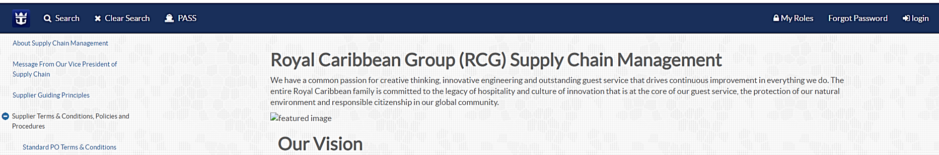

Once you are logged in you will have access to all the secured tabs and drop down menus.

# PASS – Home Page

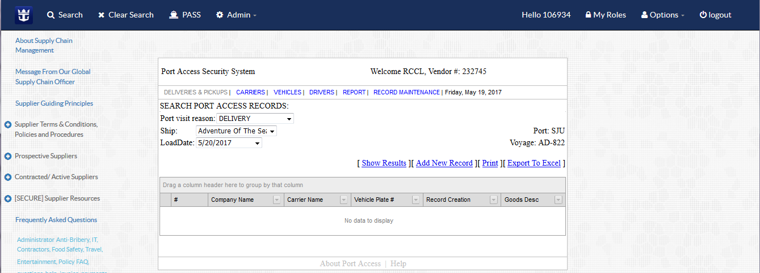

**Deliveries & Pick-ups** – Describes the Port Visit Reason *(note: if you are making a delivery on a non ‘LOAD’ date you may need to use the Pick-up options and note in the record itself that you are making a delivery.)*

**Carriers** – Supplier or Delivery Company

**Vehicles** – to Register new or review, update previously registered vehicles

**Drivers** – to Register new or review, update previously registered drivers

Report – provides option to select a Port Access Date, Port Code and Ship to download a report *(not available to all users)*

**Record Maintenance** - *(not available to all users)*

Note the tool bar, when the Section Name is grayed out; it is the file you are actually in at that time.

**Show Results** – shows any results for your company based on the ‘Port visit reason’, ‘Ship’, and ‘Load Date’

**Add New Record** – allows users to add a new delivery or pick-up record

**Print** – pulls up a PDF downloadable or printable file

**Export to Excel** – exports the file to excel *(sometimes this option does not work properly)*

# CREATING YOUR COMPANY FILES

First time users and Suppliers that have changed Supplier Number *(for any reason)* must create the following for their company or their Carrier/ Delivery Company:

* their/your Carrier’s and carrier’s used to make deliveries,
* their/your Vehicle’s, and their/your Driver’s, which will enable their/your company’s data to reside on file for easy selection by company team members in order to add delivery or pick up records.

All data entered and delivery and pickup activity is stored in the PASS database for Homeland Security access.

### Begin creating your files by selecting Carriers

* First, check that your Supplier Number is entered in the “Select Supplier” box
* If it is not there, enter your Supplier Number and click search.

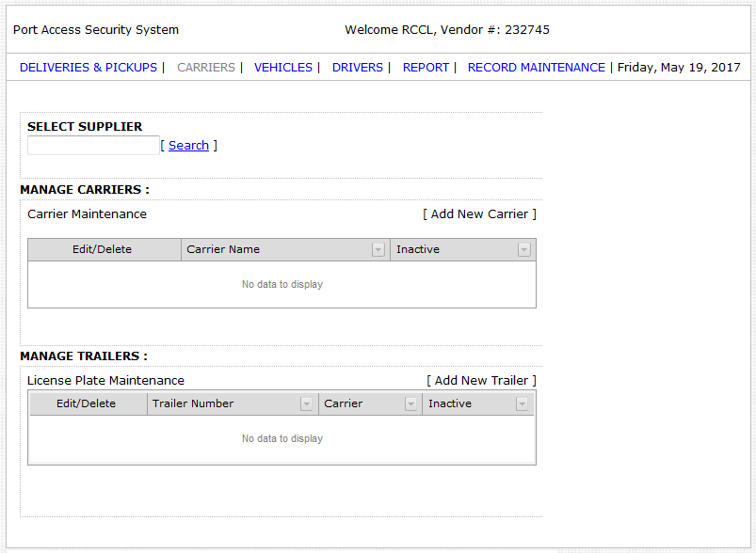

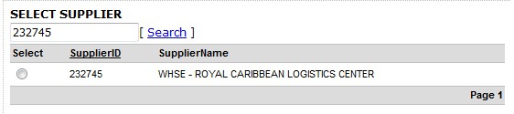

* Next, click the radio button next to your Supplier ID to activate the “Add New Carrier” option.

Selecting the Radio button activates the “Add New Carrier” functioanlity

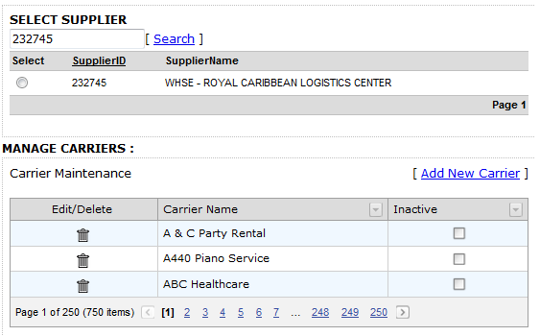

* Then, select “Add New Carrier”

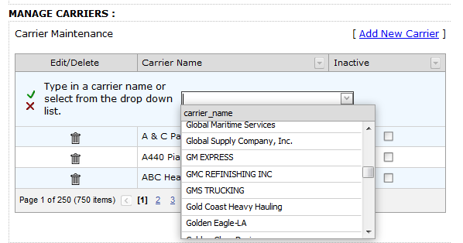

* You may add in the Carrier Name or review the drop down menu to see if the Carrier already exists and is available for selection.
  + Very important to note that it must be exactly the same as painted on the truck.

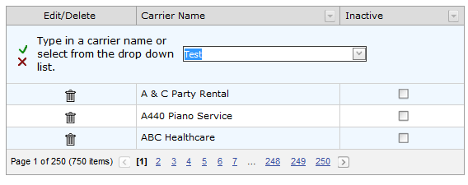

* Add & enter trailer number if it applies
* Click on the “green check mark”  in order to save it into the database.

**Manage Trailers**

* Add Trailer numbers in the appropriate area following the same process

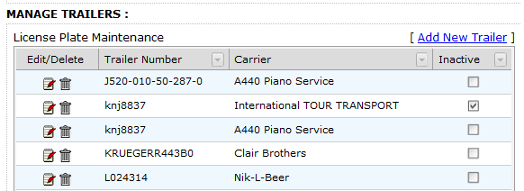

Enter the Trailer Number. The system will perform a a search to determine if the trailer already exists.

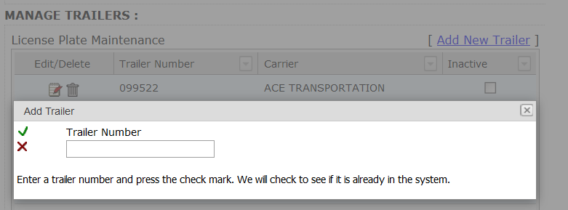

Once the search is completed, you may attach the Trailer to the appropriate Carrier in the system. Then click on the “green check mark”  in order to save it into the database.

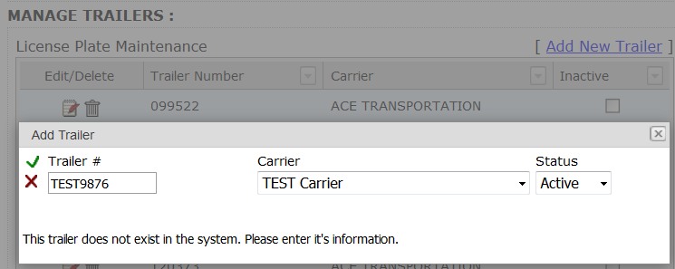

### Continue by adding the Vehicles

Once your Carrier (s) are entered you are ready to enter **Vehicles**.

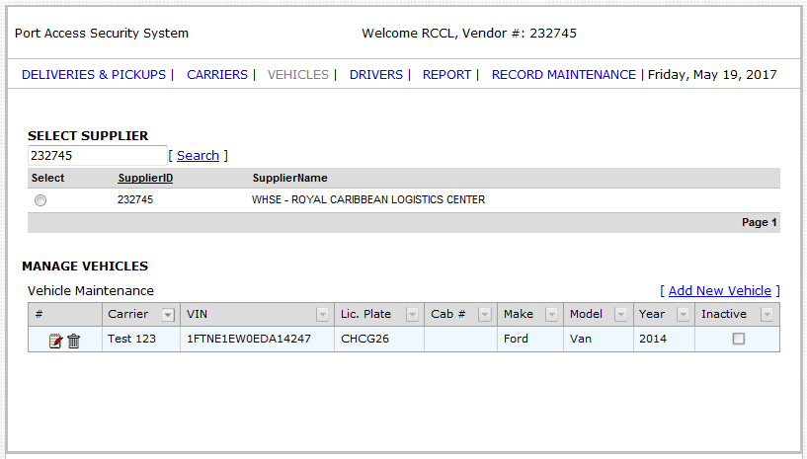

The following information is required at the time of set-up; you cannot save and return to make the entries for the vehicles:

1. Vehicle identification number (VIN)
2. Vehicle tag number – this may be called license plate number in other states
3. Make of vehicle
4. Model of vehicle
5. Year of vehicle
6. Cab number (if applicable)
7. Carrier the vehicle is associated with

* Vehicle Identification Number is also known as the VIN# – enter and be very careful as this # must match the vehicle upon arrival or will be turned away. This number never changes. Therefore you are unable to do so in the application.

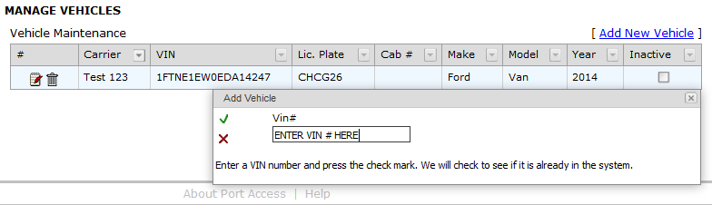

* Click on “green check mark” to save – if data is not already in the database the following fields will open up to allow you to complete entering the information
* Vehicle Registration Number / License Plate – enter and be very careful as this # must match vehicle upon arrival or will be turned away.
  + This number may be updated when the vehicle registration renewal causes a change in the tag #.
* Make of vehicle
* Model of vehicle
* Year of vehicle
* Cab number (if applicable)

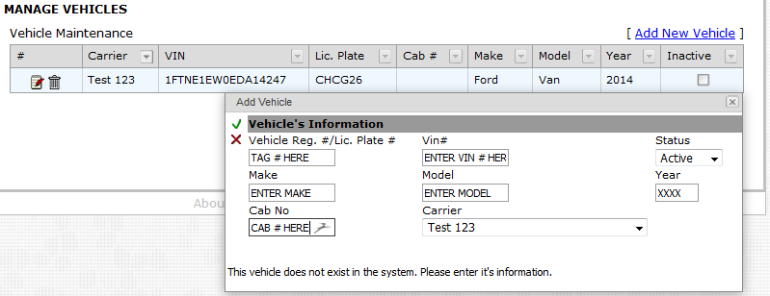

* **IMPORTANT NOTE:** **Select the** **carrier the vehicle is associated with. It is essential to match it correctly or it will not be accessible for you to create your delivery/or pickup entries correctly.**
* Make sure to utilize the carrier drop down should there be more than one carrier listed in your files when entering the vehicle.
* Once all entered - Click on “green check mark” to save

### Continue by adding the Drivers

Once Vehicles are entered move on to **Drivers**.

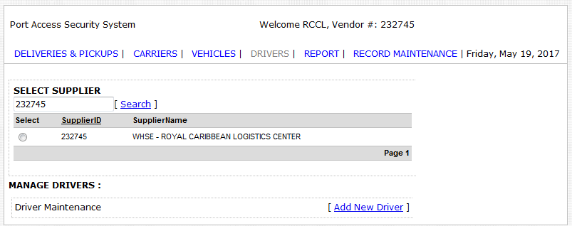

You will need the following information; you cannot save and return to make the entries for the Drivers:

1. Driver’s license number
2. Last name of the driver
3. First name of the driver
4. Drivers date of birth
5. Drivers nationality
6. Carrier the driver is associated with

* Enter the drivers’ license number - enter and be very careful as this # must match the drivers’ license upon arrival or your delivery will be turned away.

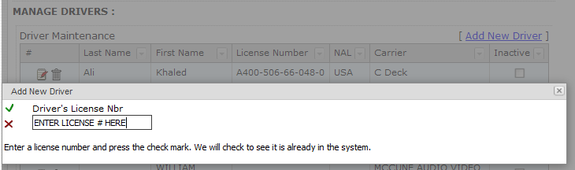

* Click on “green check mark” to save - if data not already in database the following fields will open to allow you to complete entering the information

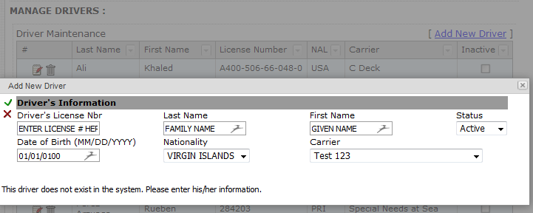

* **IMPORTANT NOTE:** **Select the** **carrier the vehicle is associated with. It is essential to match it correctly or it will not be accessible for you to create your delivery/or pickup entries correctly.**
* Make sure to utilize the carrier drop down should there be more than one carrier listed in your files when entering the vehicle.
* Once all entered - Click on “green check mark” to save

### ACTIVE and INACTIVE file records

The application was designed to assist you in removing Carriers, Vehicles, and Drivers that are no longer affiliated with your company/on leave, etc. for easy access to those Carriers, Vehicles and Drivers that are actively part of your file for your firm.

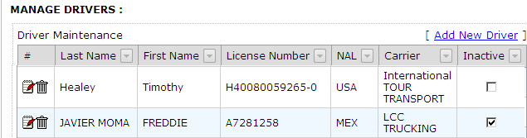

**SPECIAL NOTE:** There is no limitation to the number of Carriers, Vehicles and Drivers you can enter into your files. In fact, as business changes occur within your organization you have access to inactivate Carriers, Vehicles, and Drivers from your file that are no longer active. Should they become active again, they can easily be re-activated by searching by name and clicking on the inactive button to remove the check mark. This will re-activate the record.

# CREATING A DELIVERY or PICKUP RECORD:

Select the Delivery/Pickup tab if you are in another tab, or if you are opening the application it will automatically default to that entry page.

* Select the “Port visit reason” drop down option – Delivery/Pickup*
* When the selection chosen is Delivery
* Select the Ship via drop down; all ships are listed
* The “Loading Date” will automatically default to the “Master Loading Schedule” also known as the MLS

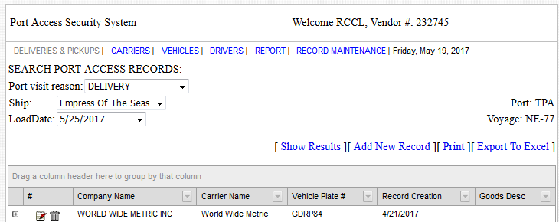

* \***SPECIAL NOTE:** If the **date of your delivery** does not appear for you to select under “DELIVERY”, it may be due to the fact that the ship is in port **but is not scheduled to receive deliveries during the port call. This means all required Port services need to be requested via the Port Agent and/ or Project Team.**

*RCL Logistics does not make arrangements for Port services on dates not scheduled on the Master Load Schedule (MLS).*

* + For those instances, choose “PICKUP”.

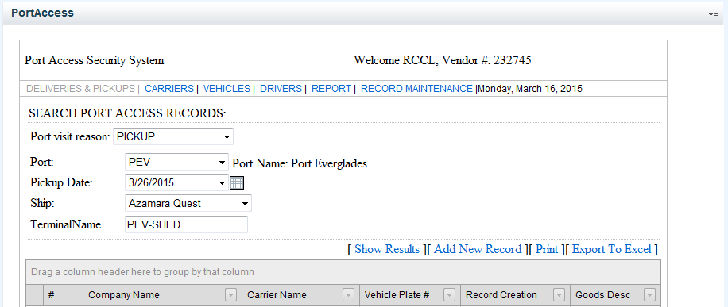

* + When choosing the option “PICKUP” it will provide you the flexibility needed in the date selection.
  + Click on calendar for date selection, and make the other necessary selections in order to make your entry.

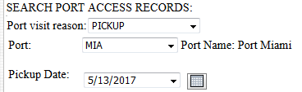

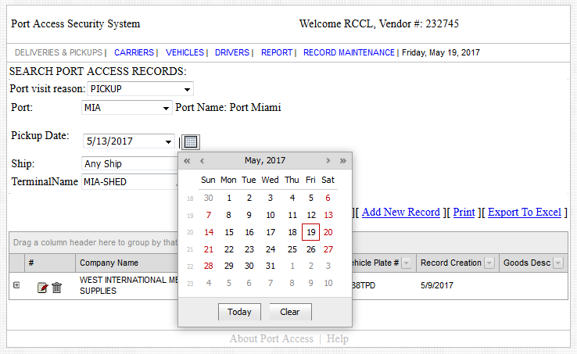

Once all criteria for the delivery/pickup has been defined by your selections, click on “Add New Record”

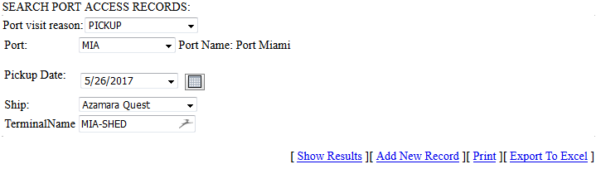

You will be moved to the actual page where you will select all data related to that delivery/pickup event, see example below:

* Select the carrier that will take the goods directly to the pier of the ship
* In the free text box, title under the box “Goods Description” enter what you are delivering; providing the # of pallets/weight and content. Example: 3 pallets/wt 1006#s Dry Groceries. Please complete this entry. In the event Homeland Security, USPH, or the Coast Guard is at the port making an inspection it may not hold up your delivery for not entering the products that are to be delivered. It also assists the port in providing labor for loadings as well as the ship personnel as to what is coming onboard on that day.
* Select the Drivers name from the drop down (the selections made from the dropdowns is taken and matched with the data in the file for drivers) Select Asst Drivers name from the drop down > RCL recommends a backup driver listed for this selection to avoid emergencies if selected driver is out sick or re-assigned (this is taken and matched with the data in the file for drivers)
* Select Vehicle by the vehicles tag#/License plate number & trailer # if applicable from the drop down (this is taken and matched with the data in the file for vehicles)
* Please note this is a selection page only the items that are grayed out do not have a relationship with your selections.
* Once all is selected, at lower right click on “Save” to save your entry
* Once saved the entry will appear on your screen in a summary format, which if necessary can easily be amended prior to the delivery.
* However, **if your update is outside of the 48 hr** window you will need to contact the Port Agent notifying them of the change to ensure it is listed correctly on the schedule given to the Port Authorities in order to ensure the driver’s entry into the port and loading or pick-up of product is not delayed or missed.

**Example of record entry shown on next page**

* **Please note any grayed out data does not relate to the selections made.** Actual delivery data selected and entered shown below

EXAMPLE NEW RECORD ENTRY:

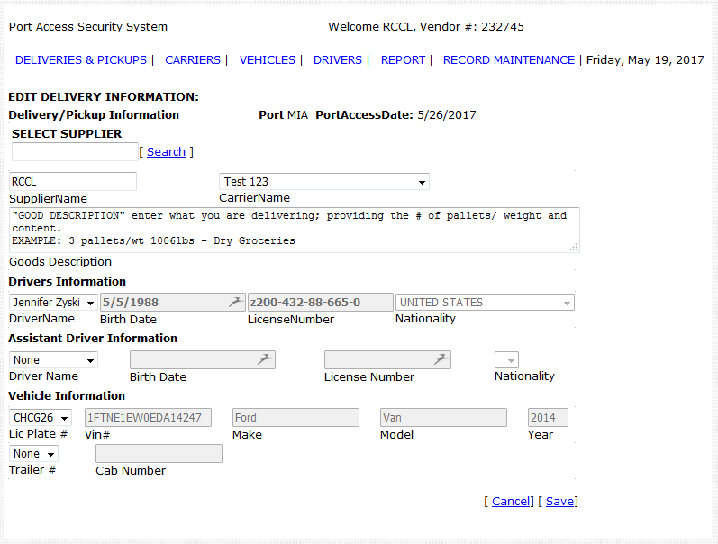

NOTE:

The Birth Date, License Number & Nationality are grayed out in this page. The information displayed in these fields may appear incorrect – do not worry, this is okay.

ONLY the Driver Name, Assistant Driver, License Plate # and Trailer # being selected will appear in the saved record you are creating.

# ACCESSING DELIVERY/PICKUP REPORTS:

There are several ways to access reports.

Suppliers, Shipboard Inventory Managers, Shipboard Security Officers, Port Agents and Shoreside Logistics, Fleet Services and other staff members may access reports for delivery/pickup in PASS. Below are instructions for accessing reports:

* After your entries have been made your screen will return to the DELIVERY default page, or the PICKUP default page. At that point you can select “print” right from the same page see below:

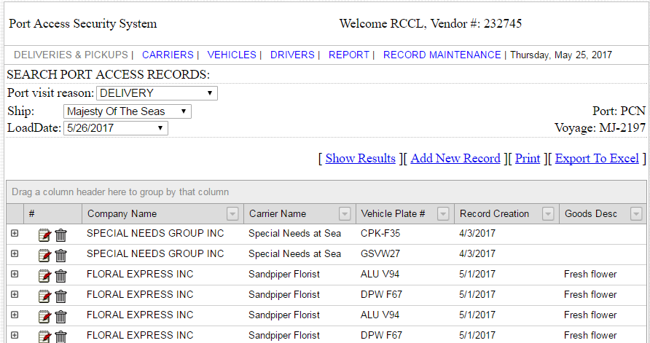

Print

Notice Port & Voyage Number

* It will result in an Adobe PDF web screen for review, download/ save and/ or print. Note the report will identify when you entered the data in the system.

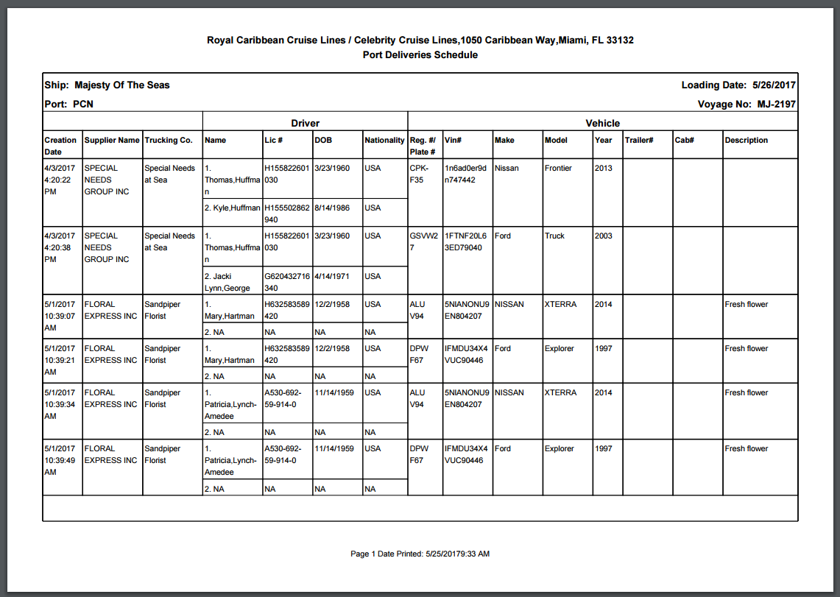

* Schedules may also be Exported to Excel

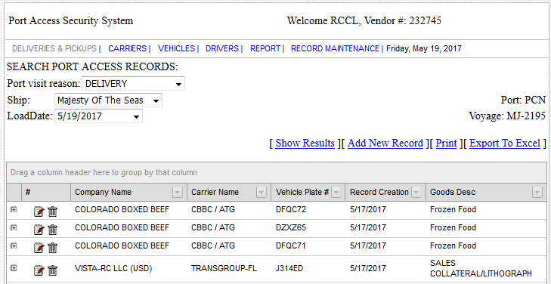

Export to Excel

Sample of Excel Export:

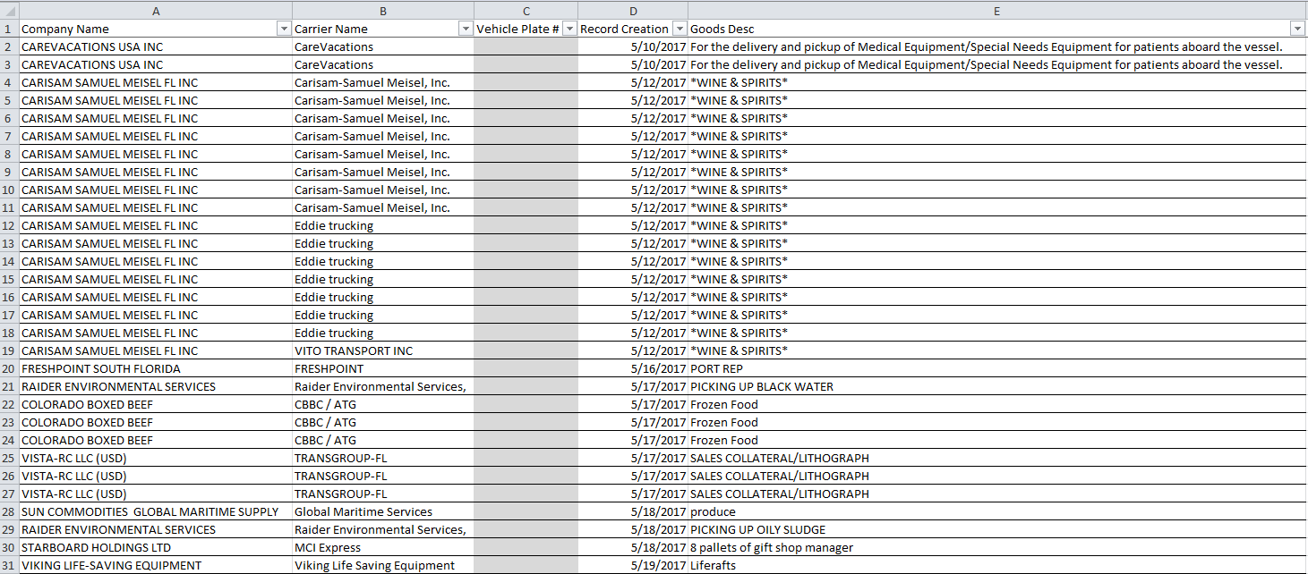

* Pick-up Entries must be printed from the “Pick-up” page.
* When you need to make a DELIVERY on a non-Load date, meaning the date/ port/ ship is not available on the ‘Delivery’ page. You may enter the details on the Pick-up page, which allows you to select any date/port/ship combination. In the “Goods Description enter the word “Delivery” followed by the description of the goods being delivered.
* PICK-UP page example.

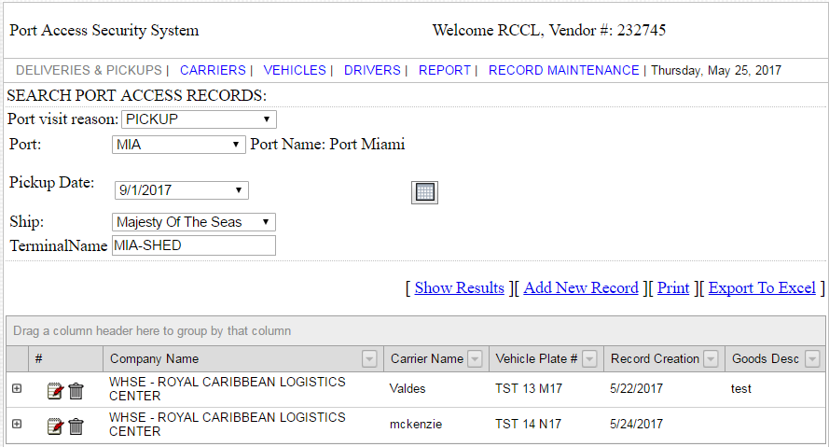

Print

It will result in an Adobe PDF web screen for review, download/ save and/ or print. Note the report will identify when you entered the data in the system.

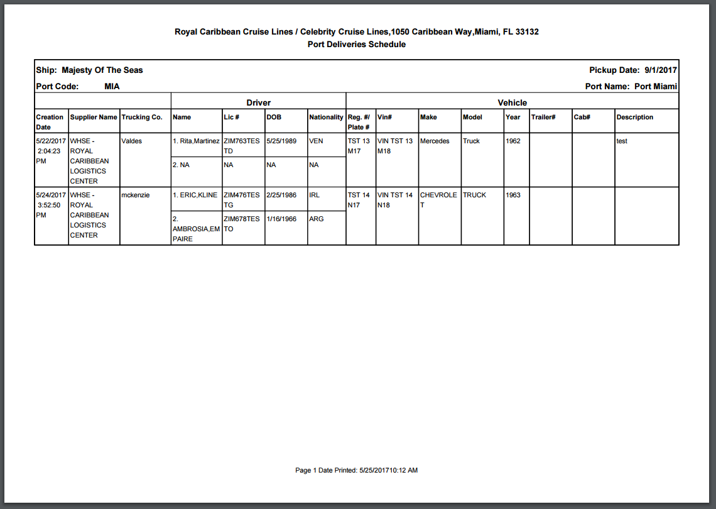

Please note based on US Port Security requirements either the RCG/Port Agent OR Ships Personnel must provide the Delivery and/or Pick-up report to the Port Security Agency in the respective Port in advance of deliveries.

Port Security will not accept the Pick-up and/or Delivery report from suppliers as entry authorization for the port to make the scheduled delivery or pick-up.

The Delivery and/or Pick-up report handed to Port Security Agency should come from the Report tab as it will include all the deliveries/ pick-ups entered in the PASS application prior to it being printed. Keep in mind all PICK-UPS and DELIVERIES must be printed from their respective pages individually and each report must be presented to Security at the Port for the specific day.

As a supplier; as an Inventory Manager or shipboard personnel; or as a Port Agent you may access them through the default page via the “REPORT” tab. This is done in the following manner:

Select the Delivery date via the calendar or the drop down

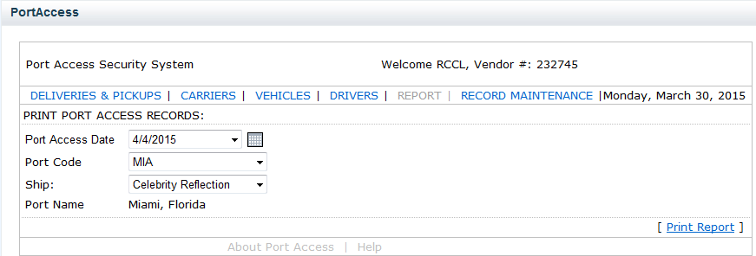

Click ‘**Print Report**’ when ready to print

Select ‘**Report**’ from the Tool Bar

Select:

**Date** from the drop down menu or Calendar feature

**Port** from the drop down menu

**Ship** from the drop down menu

Select the Port for the delivery and the ship for delivery.

Click on Print Report, it will not actually print an Adobe report will appear for your review with the list of deliveries for that date, port and ship. Then the report can be printed.

The following is a snapshot of what the report looks like which will capture all the entries made for deliveries entered in the application. Notice the headers are different when printed from the default page “print” and the “REPORT” page printed.

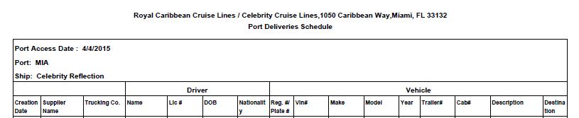

**PLEASE BE REMINDED THAT ALL PICKUPS MUST BE PRINTED FROM THE PICKUP DEFAULT PAGE IN ORDER TO CAPTURE PICKUP ENTRIES FOR SECURITY.**

## HANDLING AN EMERGENCY:

In the event a last minute emergency occurs. Such as a vehicle is in an accident or you have a last minute change of vehicle/driver for any reason you must:

* + 1. **Update PASS** application with the correct data
    2. **Notify the Port Agent** of the change and obtain instructions regarding the emergency change procedures for the specific port of call
    3. **Notify your Fleet Services Agent** of the change
       - Phone Number: 786-253-4499
       - FleetServices[two letter ship code]@rccl.com

(example: Adventure of the Seas: FleetServicesAD@rccl.com)

**PASS Instructions for Emergency last minute order received within 48 hour window**:

1. When entering data in PASS be sure to include the Goods Description.
   1. Example: EMERGENCY ORDER Received today. 1 pallet/weight 300# of mixed dairy products.
2. Notify the Port Agent that arrangements have been made to supply them with the last minute order coordinated by the ship and Fleet Services.

**\*\*If you have an emergency or need email contact with the Fleet Service Office on the weekend please address the email *To* the Fleet Service Box and *CC* the Lead Agent for the Day. This will ensure a timely response to your email request or concern**\*\*

**For issues involving container shipments or Logistics Center information you may contact**:

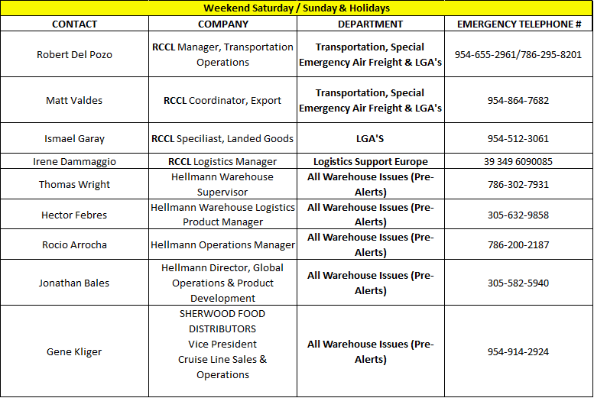

# Troubleshooting Errors:

### Error Messages:

You will receive an **error message** if you try to create a driver, vehicle or trailer record without having a valid Carrier record created.

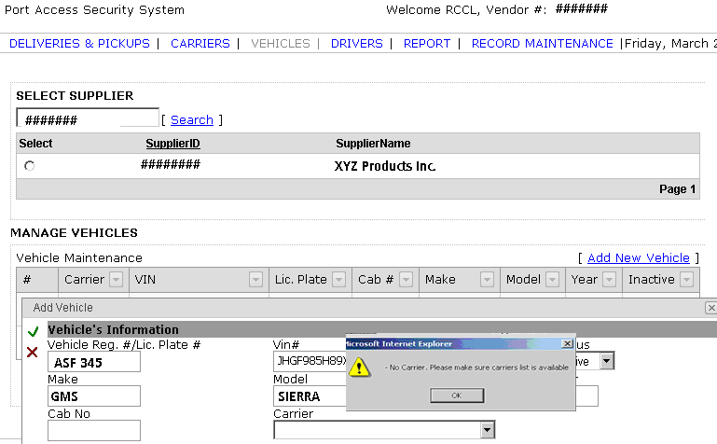

You will receive an error message if you attempt to enter a person’s name or a vehicle that already exists in the PASS system under a differnt carrier or supplier.

### 